Solution: Modes

Acme insurance has additional "Specialty Info" details for ABAutoRepairShop contacts and ABMedicalCareOrg contacts that the current user interface does not display. In each case, the Company Info card should display these fields below Employees list.

In this lab, you will create several modal input sets.

Requirements

This lab requires that you use TrainingApp 8.0, Guidewire Studio 8.0, and a supported web browser. To view, edit, and delete various contacts, log in to TrainingApp as Alice Applegate. The default URL for TrainingApp is <http://localhost:8880/ab/ContactManager.do>. The login/password for Alice Applegate is aapplegate/gw.

Tasks

1. Create a set of modal input sets, each of which has an ABContact root object, in the traininglabs PCF Folder. The first input set—the default input set—needs no widgets. It should be empty.  
   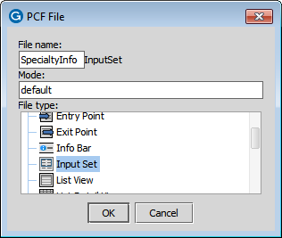  
   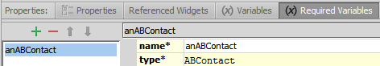
2. The second input set, for ABAutoRepairShop contacts, needs the following widgets:   
   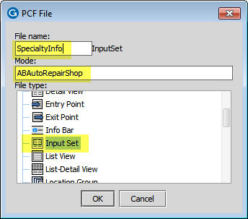  
   

* A label widget that is labeled "Auto Franchise Info"   
  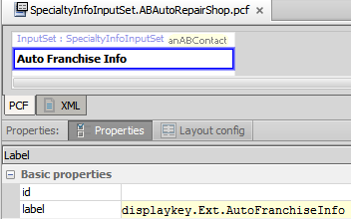  
  1. An editable input widget labeled "Franchise" that maps to ABAutoRepairShop's IsFranchise field.   
       
     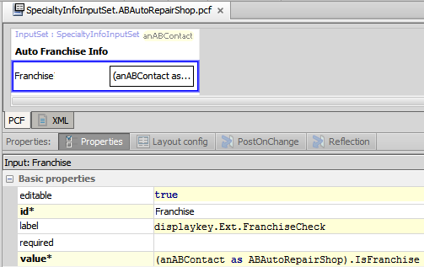
* An editable input widget labeled "Towing Provider" that maps to ABAutoRepairShop's TowingProvider field.   
  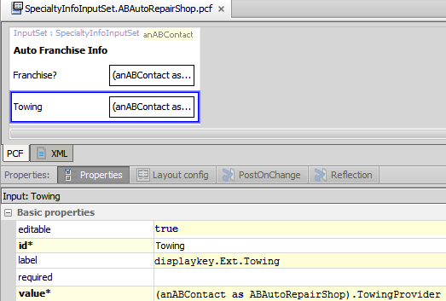

1. The third input set, for ABMedicalCareOrg contacts, needs the following widgets:   
     
   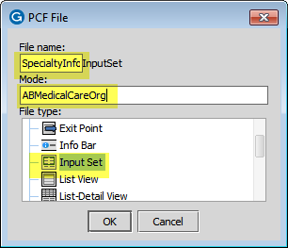



* A label widget that is labeled "Network Info"   
  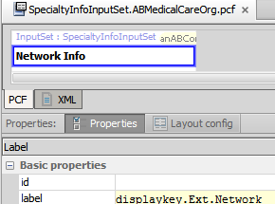
* An editable input widget labeled "Network Member" that maps to ABMedicalCareOrg's IsMemberOfNetwork field.   
  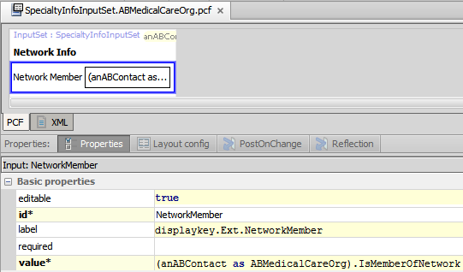
* An editable input widget labeled "Network Name" that maps to ABMedicalCareOrg's NetworkName field.   
  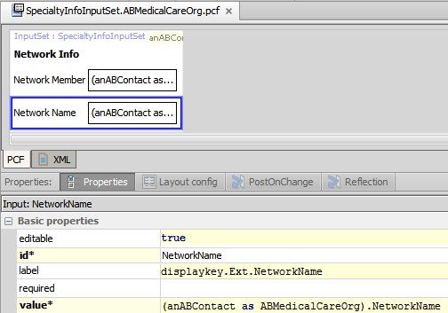

1. Add a reference to the modal container set on the Details screen's Company Info card directly under the Employees list.  
   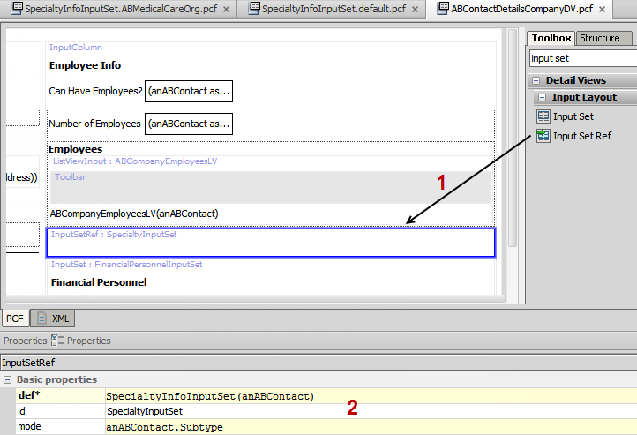

* For ABAutoRepairShop contacts (such as Burlingame Saab), the first input set should be displayed.
* For ABMedicalCareOrg contacts (such as HealthSouth), the second input set should appear

|  |  |
| --- | --- |
|  | Stop and ask your instructor to review your completed lab or compare the solutions with the provided solution set. |
|  |  |